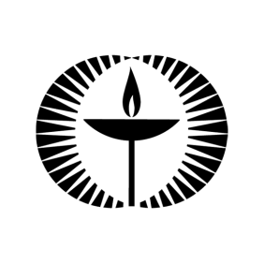

**Touchstones**

***Netcards***

**Creation Netcards with Text**

Apple Tree HRJ

Bee HRJ

Behave HRJ

Butterfly HRJ

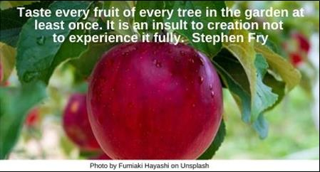

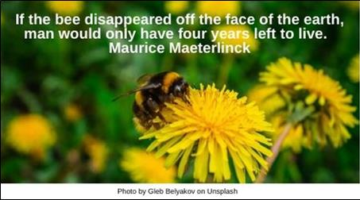

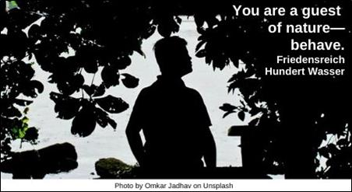

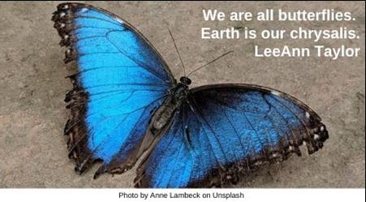

Care HRJ

Children HRJ

Clay HRJ

Clearcutting HRJ

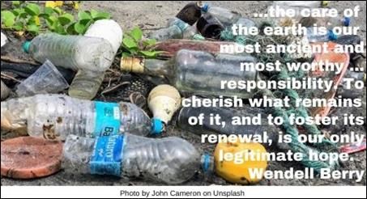

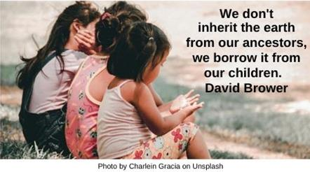

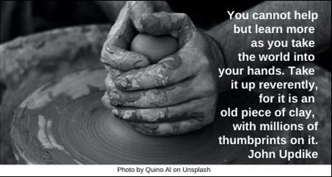

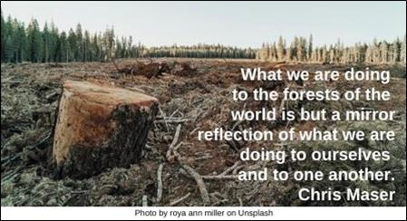

Crisis HRJ

Desert Flower HRJ

Difficult Crossroad HRJ

Earth Rise HRJ

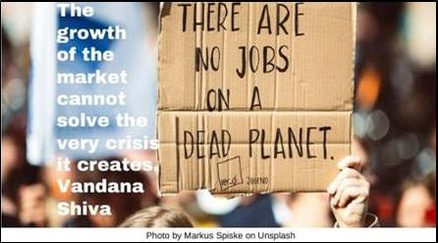

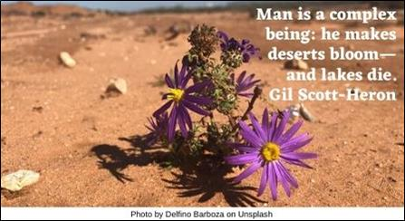

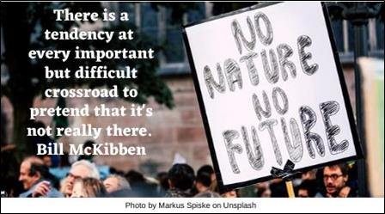

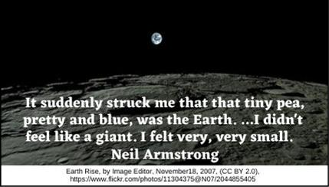

Flag of Earth HRJ

Footprints HRJ

Gardening HRJ

Harvest HRJ

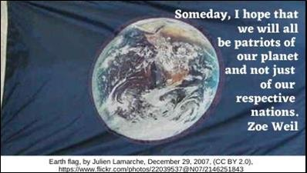

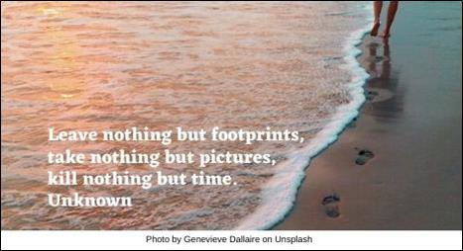

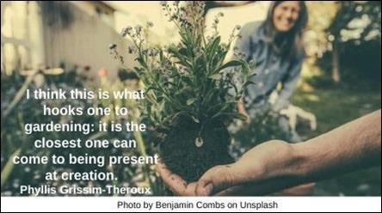

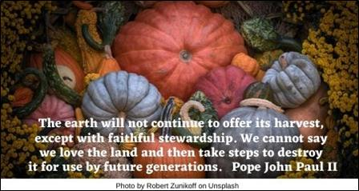

Nature HRJ

Planet Earth HRJ

Prairie Grass HRJ

Progress HRJ

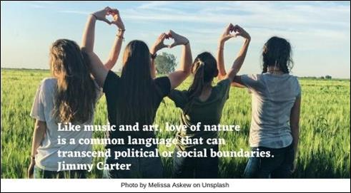

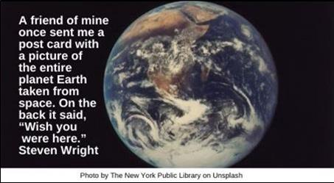

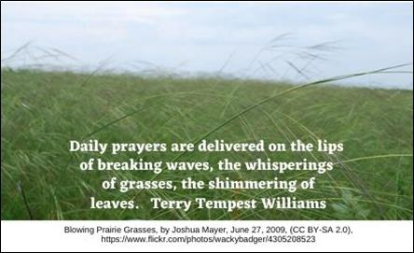

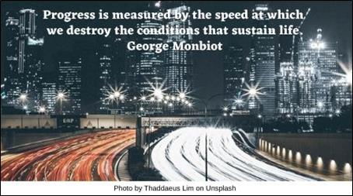

Radiance HRJ

Still Life HRJ

Thoreau HRJ

Too Wonderful HRJ

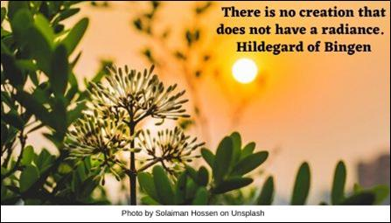

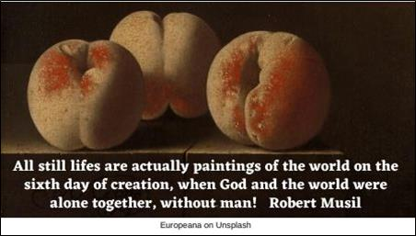

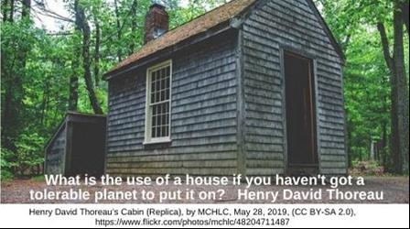

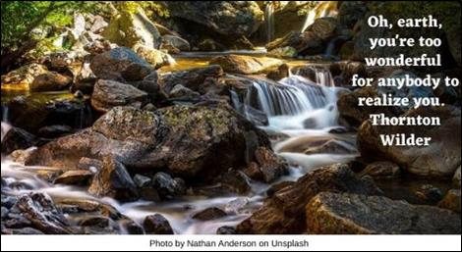

Trees HRJ

Tug HRJ

Universe HRJ

van Gogh HRJ

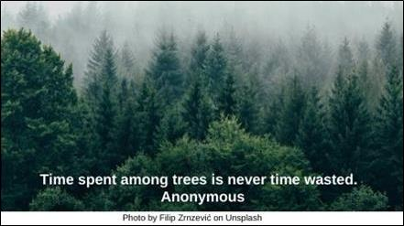

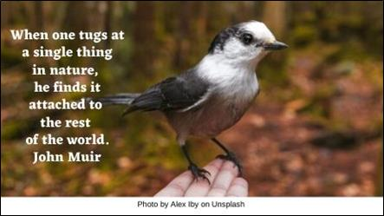

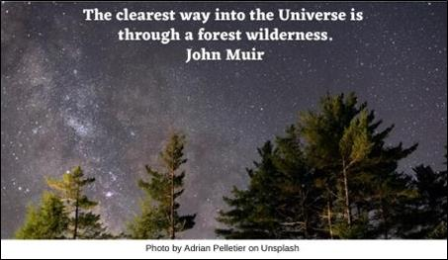

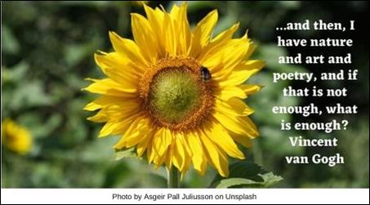

Water HRJ

Western Civ HRJ

Worship Service HRJ

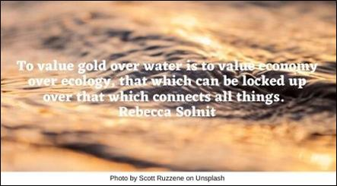

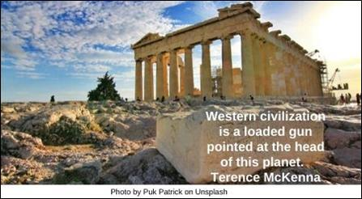

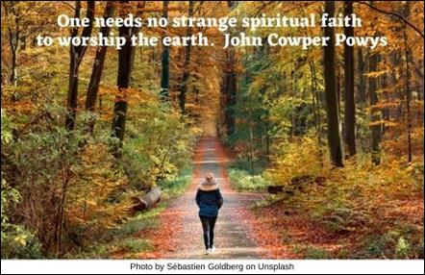

**Text of Quotes**

Apple Tree HRJ

Taste every fruit of every tree in the garden at least once. It is an insult to creation not to experience it fully. Stephen Fry

Bee HRJ

If the bee disappeared off the face of the earth, man would only have four years left to live. Maurice Maeterlinck

Behave HRJ

You are a guest of nature—behave.

Friedensreich Hundert Wasser

Butterfly HRJ

We are all butterflies. Earth is our chrysalis. LeeAnn Taylor

Care HRJ

...the care of the earth is our most ancient and most worthy …responsibility. To cherish what remains of it, and to foster its renewal, is our only legitimate hope. Wendell Berry

Children HRJ

We don't inherit the earth from our ancestors, we borrow it from our children. David Brower

Clay HRJ

You cannot help but learn more as you take the world into your hands. Take it up reverently, for it is an old piece of clay, with millions of thumbprints on it. John Updike

Clearcutting HRJ

What we are doing to the forests of the world is but a mirror reflection of what we are doing to ourselves and to one another. Chris Maser

Crisis HRJ

Nature shrinks as capital grows. The growth of the market cannot solve the very crisis it creates. Vandana Shiva

Desert Flower HRJ

Man is a complex being: he makes deserts bloom—and lakes die. Gil Scott-Heron

Difficult Crossroad HRJ

There is a tendency at every important but difficult crossroad to pretend that it's not really there. Bill McKibben

Earth Rise HRJ

It suddenly struck me that that tiny pea, pretty and blue, was the Earth. …I didn't feel like a giant. I felt very, very small. Neil Armstrong

Flag of Earth HRJ

Someday, I hope that we will all be patriots of our planet and not just of our respective nations. Zoe Weil

Footprints HRJ

Leave nothing but footprints, take nothing but pictures, kill nothing but time. Unknown

Gardening HRJ

[I think this is what hooks one to gardening: it is the closest one can come to being present at creation.](https://www.azquotes.com/quote/668594?ref=creation) Phyllis Grissim-Theroux

Harvest HRJ

The earth will not continue to offer its harvest, except with faithful stewardship. We cannot say we love the land and then take steps to destroy it for use by future generations. Pope John Paul II

Nature HRJ

Like music and art, love of nature is a common language that can transcend political or social boundaries. Jimmy Carter

Planet Earth HRJ

A friend of mine once sent me a post card with a picture of the entire planet Earth taken from space. On the back it said, “Wish you were here.” Steven Wright

Prairie Grass HRJ

Daily prayers are delivered on the lips of breaking waves, the whisperings of grasses, the shimmering of leaves. Terry Tempest Williams

Progress HRJ

Progress is measured by the speed at which we destroy the conditions that sustain life. George Monbiot

Radiance HRJ

There is no creation that does not have a radiance. Hildegard of Bingen

Still Life HRJ

[All still lifes are actually paintings of the world on the sixth day of creation, when God and the world were alone together, without man!](https://www.azquotes.com/quote/210051?ref=creation) Robert Musil

Thoreau HRJ

What is the use of a house if you haven't got a tolerable planet to put it on? Henry David Thoreau

Too Wonderful HRJ

Oh, earth, you're too wonderful for anybody to realize you. Thornton Wilder

Trees HRJ

Time spent among trees is never time wasted. Anonymous

Tug HRJ

When one tugs at a single thing in nature, he finds it attached to the rest of the world. John Muir

Universe HRJ

The clearest way into the Universe is through a forest wilderness. John Muir

van Gogh HRJ

...and then, I have nature and art and poetry, and if that is not enough, what is enough? Vincent van Gogh

Water HRJ

To value gold over water is to value economy over ecology, that which can be locked up over that which connects all things. Rebecca Solnit

Western Civ HRJ

Western civilization is a loaded gun pointed at the head of this planet. Terence McKenna

Worship HRJ

One needs no strange spiritual faith to worship the earth. John Cowper Powys